**Connecting Database and Dump the Sql File**

🡪First Download and install PgAdmin in your local machine

* Open the PgAdmin and connect to the database server
* Right Click on Servers and Create🡪 server

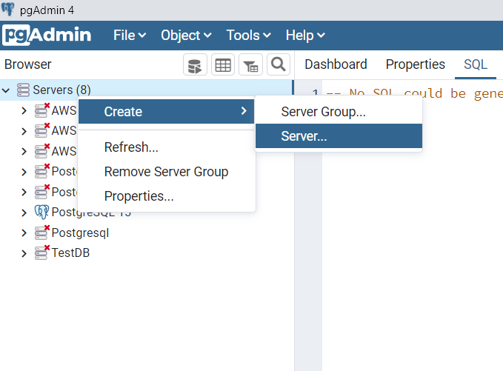

* Provide the server properties

Name : AWS-RDS-New (Any name your wish)

Host name/address : Your database endpoint

Port : 5432 (your database port number)

Username : postgres (your database username)

Password : postgres (your database password)

* Provide Server Name in **General** tab

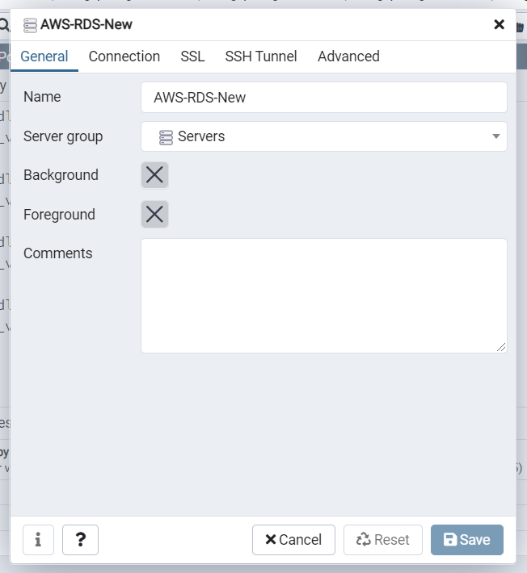

* Provide Remaining properties in **Connection** tab

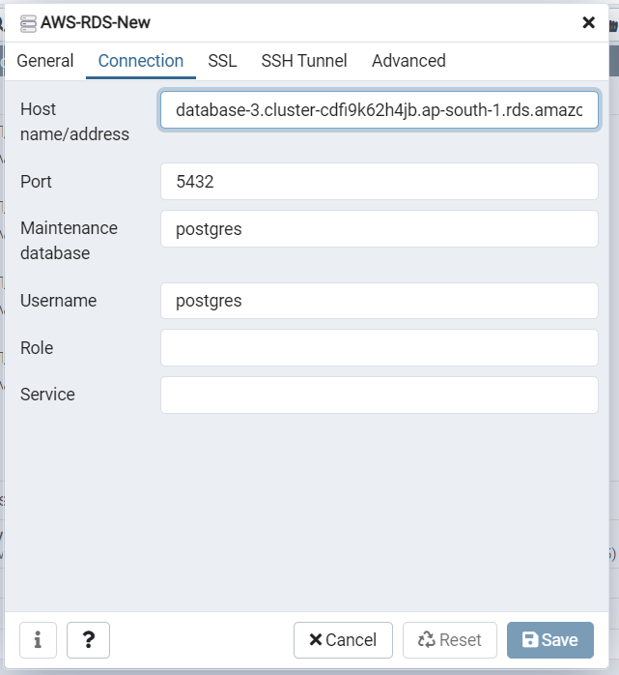

* After Creating Server ,expand the server and right click on databses and create database

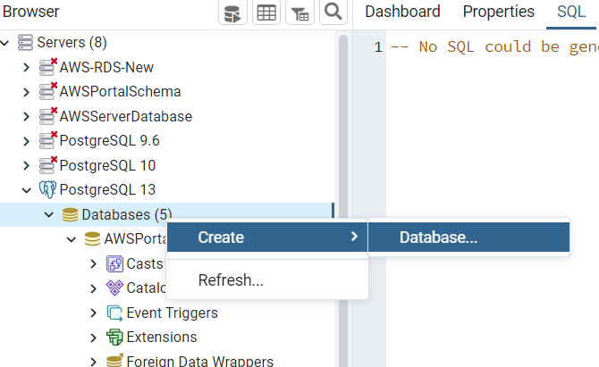

* Provide the Database Name in **General** tab and click on save .

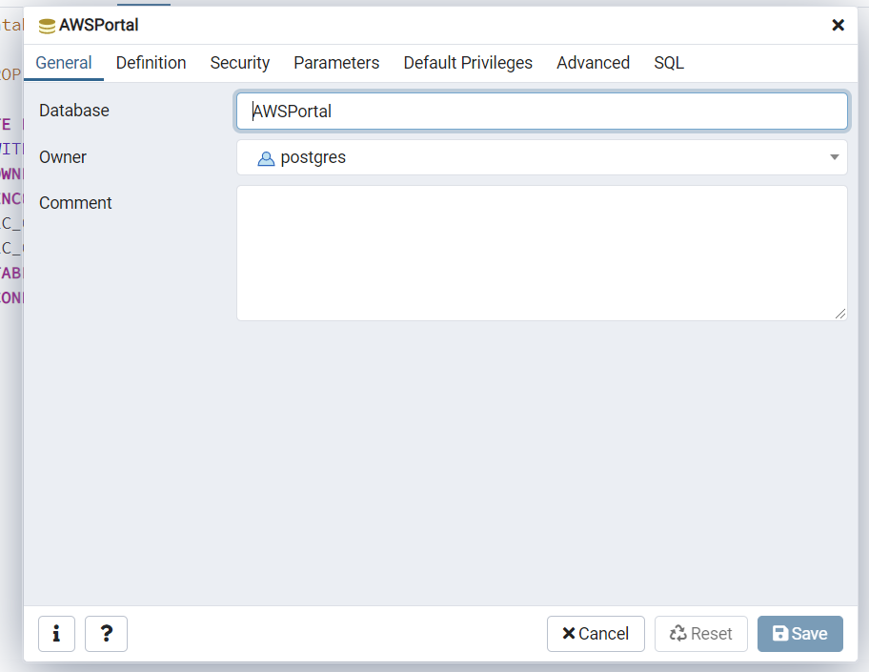

* It will create the database
* Right click on created database and click on Restore

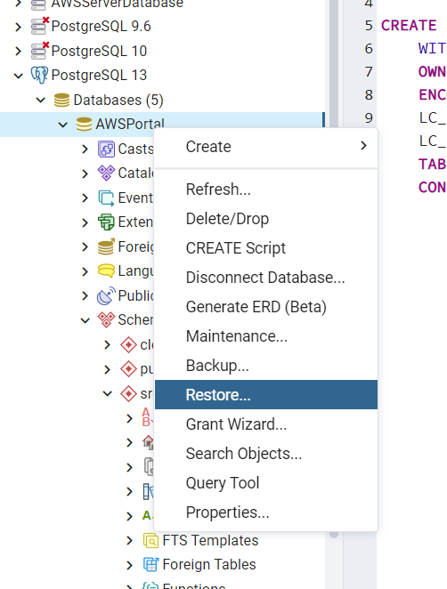

* It will open the window in that click on filename and select your .sql file

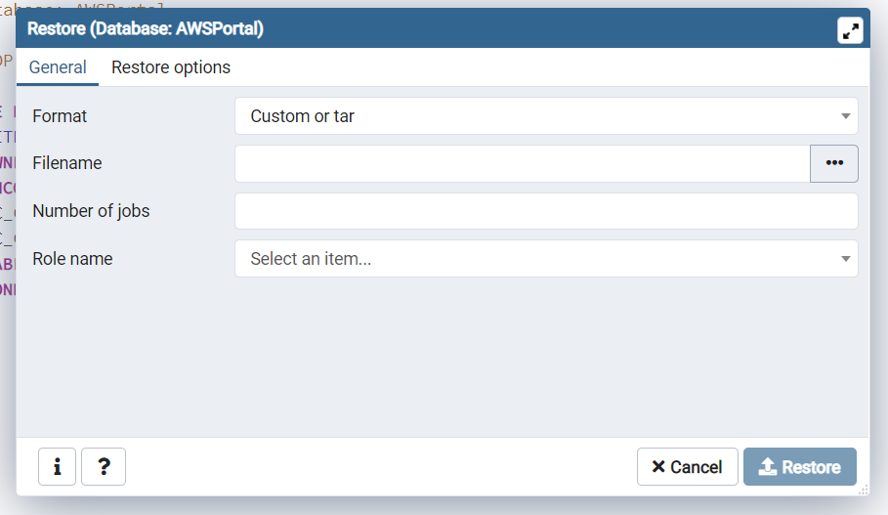

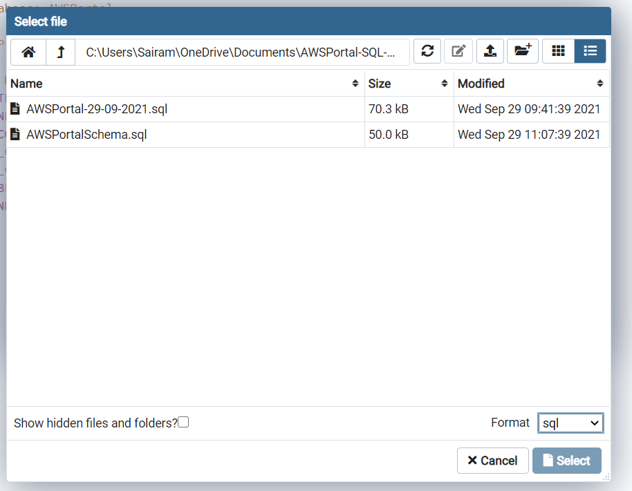

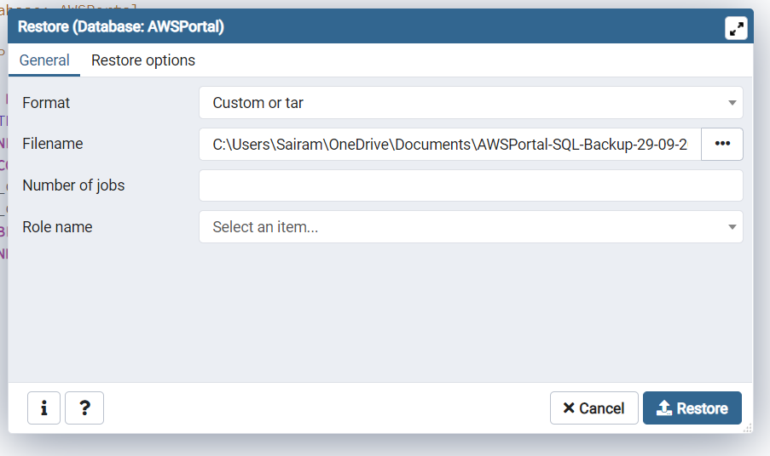

* Click on Restore
* It will Dump the schema in your database